NAME : Shashank Bagda

Enrollment No: 92100133020

**Instructions:**

**1. Attempt all questions.**

**2. Make suitable assumptions wherever necessary.**

3. Figures to the right indicate full marks.

|  |  |  |
| --- | --- | --- |
| **Q1** | **Do as directed (Attempt any Two) (CO3, CO4)** | **20** |
| 1 | Write a python code that takes in a sentence as input and displays the number of words, number of capital letters, no. of small letters and number of special symbols.  **Input:** @Python is a computer programming language.  **Output:**  Number of words: 6  Number of capital letters:1  No. of small letters: 35  Number of Special Symbols:1 | **10** |
| 2 | Write a python code that takes in a sentence as input and displays the number of words which frequently used in the paragraph.  **Input:** Cell-free massive MIMO major goal is to virtually assemble a massive MIMO system from a set of geographically.  **Output:**  No. of words: 2 (a, Massive MIMO) | **10** |
| 3 | Write a python code for sort the elements in the given array using Numpy   1. Sort the whole array 2. Sort along each row 3. Sort along each column   **Input:**  **Output:**  (1)  (2)  (3) | **10** |
|  |  |  |

TASK 1

sen = input("Enter the String : ")

str_capital = 0

str_small = 0

str_special = 0

str_word = 0

for i in range (len(sen)):

if(sen[i] > 'A' and sen[i] < 'Z'):

str_capital = str_capital + 1

if(sen[i] > 'a' and sen[i] < 'z'):

str_small = str_small + 1

if(sen[i] == '!' or sen[i] == '@' or sen[i] == '#' or sen[i] == '$' or sen[i] == '%' or sen[i] == '^' or sen[i] == '&' or sen[i] == '*' or sen[i] == '(' or sen[i] == ')'):

str_special = str_special + 1

if(sen[i] == ' '):

str_word = str_word + 1

print("Number of Words : ",str_word+1)

print("Number of Capital Letters : ",str_capital)

print("Number of Small Letters : ",str_small)

print("Number of Special Letters : ",str_special)

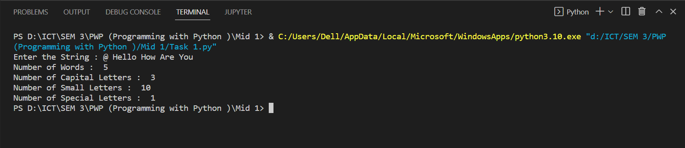

TASK 3

import numpy as np

n1 = np.array([[3,7,1], [10,3,2], [5,6,7]])

print("Entered 3x3 Matrix : \n",n1)

#(1) Sort the whole array

arr = []

for i in range (1,9):

arr = arr.append(n1)

#np.sort(arr)

print(arr)

print("\n\n(2) Sort along each row : \n",np.sort(n1))

print("\n\n(3) Sort along each column : \n",np.sort(n1.T))

